Project 8
Due 11/28/2016 by 11:59 PM
No delay is accepted
For each day late submission 2 points penalty is incurred.
Post your answer in the folder Project 8 on the blackboard.
If you have any questions please email me at mbadii@pace.edu

Note: Do not email me your project for grading. Only email your project to me when you need help and have questions. In this case attach your project and describe what your questions are.

To save me some time please name the files, folders and locations explained below. Do not change the name of the files, folders, and their locations.

The purpose of this assignment is to:
a. Make a sphere as a static mesh.
b. Write a class and connect it to the static mesh. We call the sphere a disco ball.
c. Make a hollow 512*512*512 cube with the default texture.
d. Add four disco balls to the four corners of the floor.
e. Write code such that when we play in UDK, 1, 2, 3 or 4 of the disco balls disappear.

In folder: C:\UDK\UDK-2014-08\Development\Src make a folder named: Project8. Inside this folder, make a folder named: Classes.

In folder: C:\UDK\UDK-2014-08\UDKGame\Content\Maps make a folder named: Project8.

Load UDK.

Make a sphere with Radius: 120, and extrapolation: 3. Select a texture material. I used: BoneWeightMaterial.

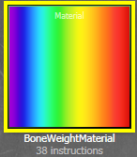

Click on CSG Add icon:
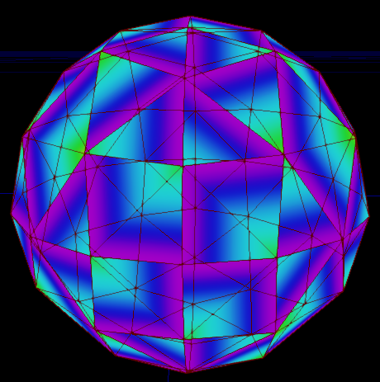

Convert the sphere to a static mesh with package: DiscoPackage, Grouping: DiscoGrouping and Name: DiscoBall:

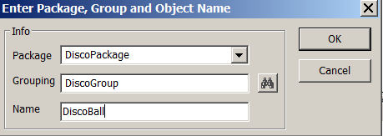

Expand the tab: Packages in the content browser and Right-click on: DiscoPackage and save the package in C:\UDK\UDK-2015-01\UDKGame\Content:

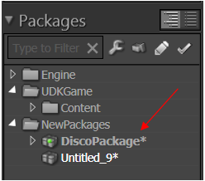

Make a hollow 512*512*512 cube with the default texture.

Add four point lights and a Player Start. Build and Play.

Save the map with the name: ForProject8 in the folder: C:\UDK\UDK-2015-01\UDKGame\Content\Maps\AllProjects/.

Close UDK and in the ConText editor, make the following class:

class Project8 extends KActor placeable;

simulated function PostBeginPlay() {
}

Save this class with the name: Project8 in the folder: C:\UDK\UDK-2015-01\Development\Src\Project8\Classes.

DefaultEngine.ini from the folder: and add: +EditPackages=Project8 to the section: [UnrealEd.EditorEngine]. Save the file and close it.

Compile the class. There should be no error on the DOS window.

Load the map: ForProject8 to UDK editor.

In the content browser, click on tab: Actor Classes. Find the class: Project8. Click on it and drag it to the cube. Put it on the floor.

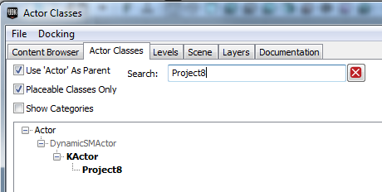

You should see:

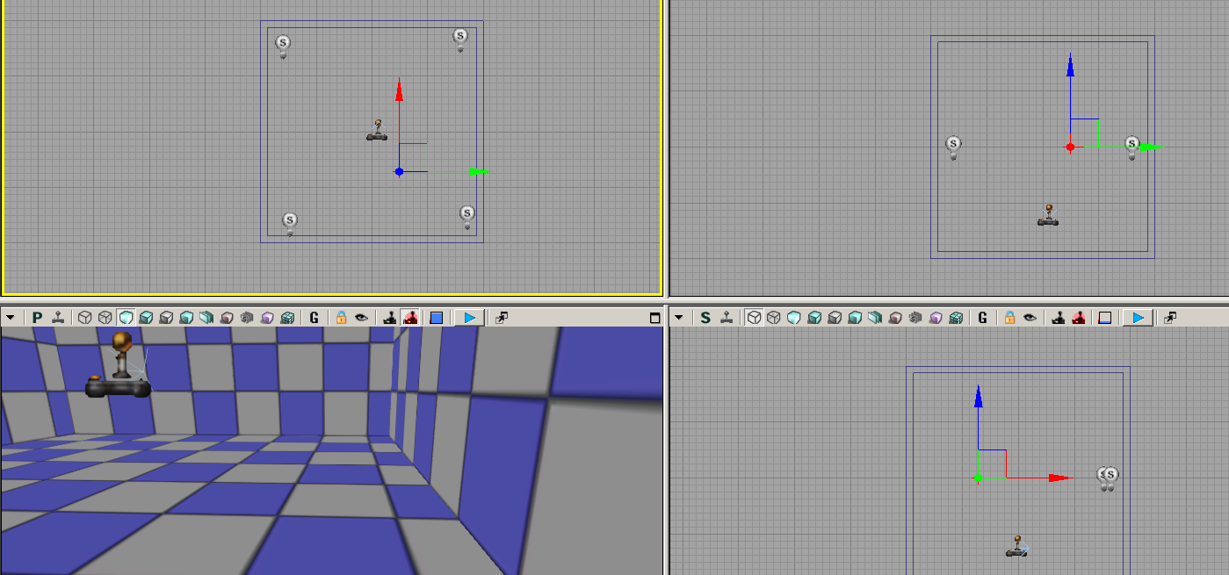

Right-click on the red arrow to load the following properties window:

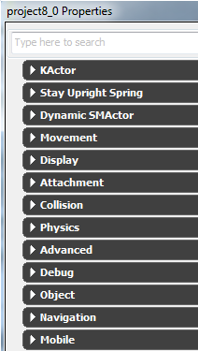

Note: you may see: Project8_0 (Or a different number).

Expand: Dynamic SMActor → Static Mesh Component → Static Mesh Component to see:

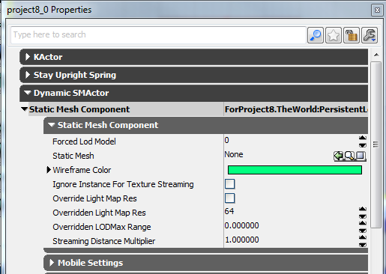

In the content browser, click on a static mesh, select the DiscoBall and add it to see:
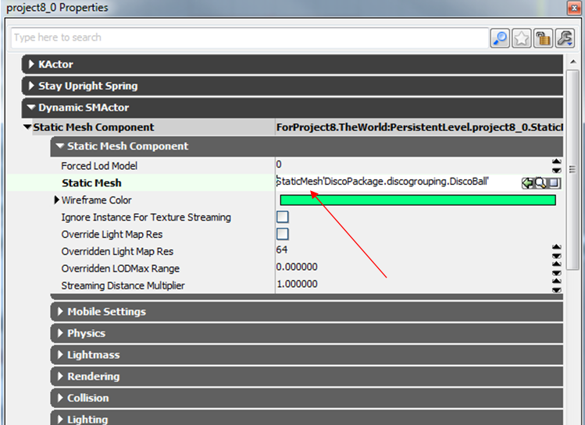

You should see:

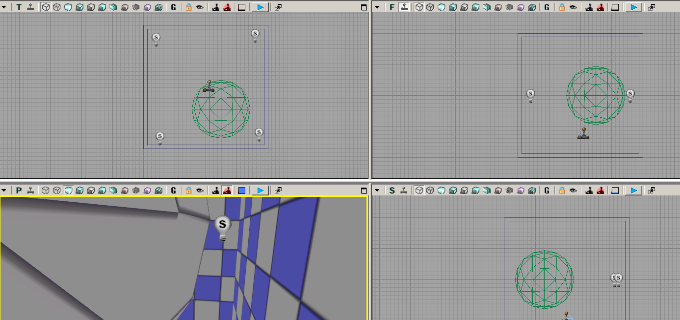

Right click on it to bring its properties window on the screen and change its draw scale to: 0.2

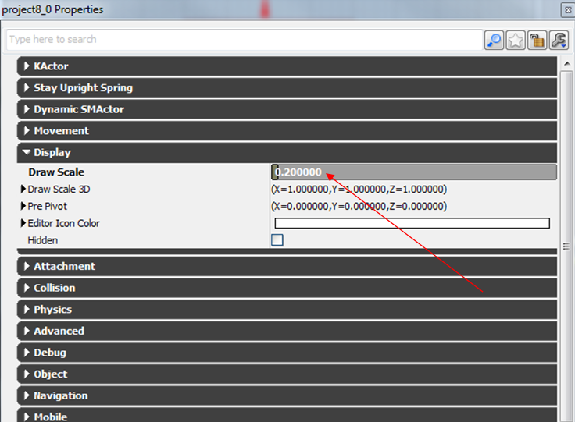

Make three more copies of the disco ball from Top viewport (and not from the content browser) and put them on the floor in the four corners:

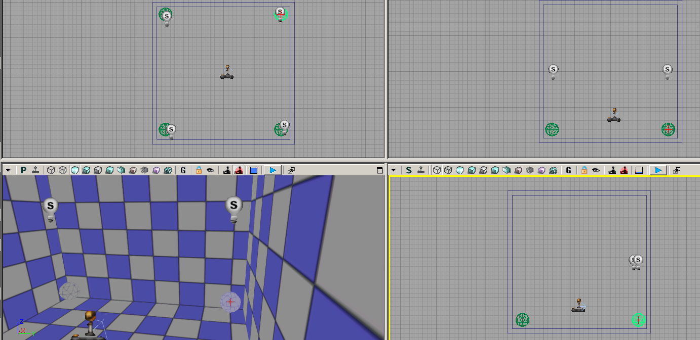

Below is your main work:

Complete the above class such that when you play, one, two, three or four discoball(s) disapear.

Hints:
1. You need to generate a random number between 1 to 4.
2. You need to use the statement: foreach-loop.
3. From lecture 8, find out how you call a function of a class.
4. Use UnCodeX, load the class: Actor. In this class, there is a function that when is called, a disco ball disappears. The call should be in a loop such that a number of disco balls disappear.

Note: You do not need to write extra functions. In my program, the body of the function: PostBeginPlay I have less than 15 lines.

How to test the program: Suppose you have:

n = Rand(…)…;

Temporary comment this line and write: n=4, compile and run. Do this for n=3, n=2, n=1, and n=0.

